*Letter to be shared with leadership of child care centers*

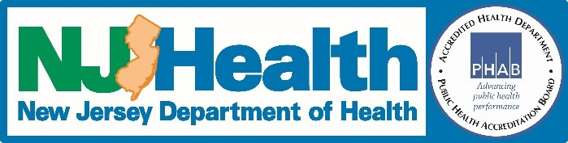

**An important message from the New Jersey Department of Health:**

The New Jersey Department of Health (NJDOH) is currently reporting widespread influenza (flu) activity in all regions of the state. The flu can be very serious and can cause severe symptoms and sometimes death. People with flu often have fever, headache, sore throat, body aches, and cough.

Please remember, that according to state health regulations, children six months through 59 months of age attending any licensed child care center, or preschool facility, must have received at least one dose of influenza vaccine by December 31, 2017. Children who do not have documentation of receiving the flu vaccine and don’t have a valid medical or religious exemption will need to be excluded from the child care center or preschool facility through March 31, 2018.

NJDOH recommends that schools and childcare settings increase education on respiratory hygiene and monitor attendees for sudden fever and respiratory illness symptoms.

Staff and children (as developmentally appropriate) should all be taught and asked to follow these steps that prevent the transmission of infections such as influenza:

* Cover your coughs and sneezes.
* Avoid touching your eyes, nose and mouth.
* Wash hands frequently, especially after coughing or sneezing.
* Stay home if you’re sick, especially with a fever.

Staff and parents should be made aware of the symptoms of influenza. Symptoms associated with the flu can include:

* Fever (although not everyone with flu has a fever)
* Cough
* Sore throat
* Runny or stuffy nose
* Body aches
* Headache
* Chills
* Tiredness
* Sometimes diarrhea and vomiting

School or childcare attendees and staff with sudden fever and respiratory illness symptoms should be sent home with instructions to stay at home until fever free for 24 hours without fever reducing medication. Instructions should be given to seek medical care with worsening of symptoms.

It is not too late to get vaccinated. All people 6 months of age and older are recommended to annually receive the influenza vaccine. Getting vaccinated yourself protects people around you, including those who are more vulnerable to serious flu illnesses, like babies and young children, older people, and people with certain chronic health conditions. While flu vaccine is not perfect and some people who get vaccinated may still get the flu, there is some data to suggest that flu vaccination may make the illness milder.

The New Jersey Department of Health asks that everyone take steps to prevent the flu:

* Get a flu shot – it’s not too late to be protected!
* Wash hands often
* Cover coughs and sneezes with your sleeve or a tissue
* Avoid sick people
* Stay home if sick. Keep students home if they are sick too

For more information go to the New Jersey Department of Health flu website at <http://nj.gov/health/cd/topics/flu.shtml>.  Follow the New Jersey Department of Health on [Twitter](https://twitter.com/NJDeptofHealth) @njdeptofhealth, [Facebook](https://www.facebook.com/NJDeptofHealth/) /njdeptofhealth, [Instagram](https://www.instagram.com/njdeptofhealth/)@njdeptofhealth and [Snapchat](https://www.snapchat.com/) @njdoh.

**School and/or Daycare Specific Resources**

**NJDOH Prevention and Control Measures for Outbreaks in School Settings:** <http://nj.gov/health/cd/topics/outbreaks.shtml#2>

**General Guidelines for the Control of Outbreaks in School and Child Care Settings**

**School Exclusion List**

<http://www.nj.gov/health/cd/documents/School%20Exclusion%20List%20_revised%207.10.2017.pdf>

**CDC Information for Schools & Childcare Providers**

<https://www.cdc.gov/flu/school/>

**Guidance for School Administrators to Help Reduce the spread of Seasonal Influenza in K-12.**

<https://www.cdc.gov/flu/school/guidance.htm>

**Handwashing Resources**

<https://www.cdc.gov/handwashing/index.html>

http://www.nj.gov/health/cd/topics/handwashing.shtml

**How to Clean and Disinfect Schools to Help Slow the Spread of Flu** <https://www.cdc.gov/flu/school/cleaning.htm>